
Resume

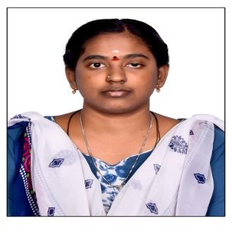
S.NARMATHA,
D/o S.M.Siva Moorthy,
12B College House Road,
Nagammal Nagar,NagalNagar, Dindigul -3.
.
Email id:narmadhamoorthy96@gmail.com
Cell no: 6383488955
PROFESSIONAL OBJECTIVE

To secure a position where I can efficiently contribute my skills and abilities to the growth of the organization and build my professional career.
ACADEMICRECORD

CLASS/COURSE | NAMEOFTHE INSTITUTION | BOARDOF STUDY | YEAR OF PASSING | MARKS (%)/CGPA
B.E(CSE) | SBM COLLOGE OF ENGINEERINGAND TECHNOLOGY, DINDIGUL | AnnaUniversity | 2018 | 75%
HSC | ANNAMALAIARMILLS GIRLS HIGHER SECONDARYSCHOOL | StateBoard | 2014 | 72%
SSLC | SOWRASHTRA SRI VARADHARAJAHIGH SCHOOL | StateBoard | 2012 | 83.6%

COMPUTERPROFICIENCY

Languages | C,C++,CORE Java, Python , Php
CrossPlatform | XAMPP,Wamp, SQL Server, Mongo DB
AREAOFINTEREST
- Software Developer
- Coding Instructor
KEYSKILLS
- Self-Motivator.
- HardWorker
- TeamWorker
- PositiveThinker
EXPERIENCE
2018 TO WORKING IN SOFTWARE TRAINER OF SIS COMPUTER ACADEMY IN STILL NOW .
PERSONALPROFILE

FATHER’SNAME : S.M.Siva Moorthy
DATEOF BIRTH : 2NDMAR 1997
MOTHERTONGUE : Tamil
AGE : 29
GENDER : Female
LANGUAGESKNOWN : Tamil,English.
NATIONALITY : Indian
RELIGION : Hindu
I hereby declare that all the information mentioned above is true to my knowledge

Date:
Venue:DINDIGUL [NARMATHA S]

